Impact of cognitive training on professional drivers' cognitive profiles and performance
Jose L. Tapiaª*, Paula Fernández^{b,c} and Jon Andoni Duñabeitia^{d}
ªDepartment of Behavioral Sciences Methodology, Universitat de València, Valencia, Spain; ^{b}Department of Psychlogy, Universidad de Oviedo, Oviedo, Spain; ^{c}People and Culture Department, Alsa, Oviedo, Spain; ^{d}Centro de Investigación Nebrija en Cognición (CINC), Universidad Nebrija, Madrid, Spain.
*Corresponding author: jose.l.tapia@uv.es
Abstract: This study explores the cognitive profiles of professional drivers and presents a pilot evaluation of a Computerized Cognitive Training (CCT) intervention, aiming to assess its feasibility and potential effects on cognitive performance and driving outcomes. To investigate how specific cognitive domains relate to real-world driving behavior, the research was structured in two experiments. Experiment 1 involved 160 professional drivers who completed cognitive assessments to examine correlations between cognitive abilities and driving safety metrics. The results revealed significant relationships, particularly noting that coordination abilities were inversely correlated with crash rates. Experiment 2 included a subset of 47 drivers from the initial group, who participated in an 8-week CCT program. Pre- and post-intervention assessments measured cognitive performance, safety metrics, and driving styles. The intervention led to significant improvements in cognitive domains, while driving styles, as expected, remained stable. However, no improvements were observed in driving metrics. In conclusion, while CCT effectively enhances cognitive performance among professional drivers, its transfer effects to driving safety metrics remain unsubstantiated. As a pilot study, these findings offer a preliminary foundation for further research to explore the relationship between cognitive enhancements and driving outcomes, and to evaluate CCT's potential in improving road safety.
Keywords: professional drivers; driving safety; cognitive profile; cognitive training; cognitive enhancement.

1. Introduction
Professional drivers, defined as individuals who drive for a living and whose primary occupation involves operating vehicles, constitute an essential segment of the workforce within the European Union, with their numbers surpassing 10.8 million, as per the latest estimates by Eurostat [1]. Of this significant figure, heavy truck and bus drivers represent 35% of those engaged in transport-related occupations. Despite accounting for a mere fraction of the overall driving population, their impact on road safety dynamics is profound. The increased propensity for traffic crashes within this demographic is multifactorially influenced by extended periods of driving, variable driving conditions, occupational stress, overconfidence, and fatigue [2,3]. It is therefore not surprising that traffic crashes represent a leading cause of occupational fatalities in industrialized nations [4].
In response to these concerns, the European Parliament in 2018 ratified Directive 2022/2561, setting forth enhanced safety measures for professional drivers [5]. This legislation mandates specific driving hours, rest periods, and periodic training to ensure drivers are updated on the latest vehicular technologies and safety protocols. However, the Directive notably omits considerations for cognitive functioning, despite extensive documentation of human factors in traffic incidents [6–8]. This oversight may point to a gap in addressing the broader needs of professional drivers, who typically possess adequate theoretical and practical expertise. The integration of practical skills with foundational knowledge necessitates consideration of personal attributes, including personality traits [9], driving styles [10], and cognitive processes [11]. These elements are instrumental in defining driving behavior and, by extension, are indispensable in safeguarding road safety, advocating for a more inclusive approach that addresses the complex dimensions of driving proficiency among professional drivers.
Regarding the cognitive dimensions of driving, it becomes evident that a comprehensive array of cognitive functions is pivotal for effectively and safely driving a motor vehicle. This includes attention, working memory, perception, executive functions, motor coordination, and judgment [12,13]. These faculties underpin the driver's ability to concentrate on pertinent stimuli, interpret sensory data, execute rapid decision-making, navigate the vehicle adeptly, and assess situations to forge secure decisions. Consider the routine scenario of navigating a traffic light at an intersection, where the signaling protocol is straightforward: green indicates proceed, amber or yellow signals caution—advising to stop if safe before the intersection, or continue if halting is unsafe, and red mandates a stop. Within this seemingly mundane task lies a complex interplay of cognitive operations, starting from sensory processing to recognize external stimuli, attention mechanisms to prioritize relevant inputs, inhibitory functions to filter out non-essential stimuli, and memory processes to merge this information with past experiences, culminating in decision-making processes that orchestrate the motor actions required for the maneuver. Beyond these mechanisms, additional elements tied to individual behavioral patterns, such as driving styles, emerge as critical determinants influencing driver conduct and overall road safety.
As per the specificities of driving styles and their consequential impact on road safety, scholarly investigations delineate a comprehensive taxonomy of driver behaviors: a) the patient and cautious driver, epitomized by a deliberate, methodical approach to vehicle operation, strict adherence to traffic regulations, and respectful interaction with fellow road users; b) the anxious driver, characterized by perpetual vigilance and a pervasive sense of tension; c) the reckless and careless driver, marked by a quest for excitement, disregard for safety norms including speed limits, and a general indifference to the welfare of others; and d) the angry and hostile driver, who displays behaviors of aggression, irritation, and a propensity for risky driving maneuvers and confrontations with other road users [14,15]. The linkage between driving style and the occurrence of traffic crashes is substantiated by empirical research, revealing that a patient and cautious driving approach correlates with a lower frequency of vehicular crashes. In contrast, styles characterized by recklessness, carelessness, anger, and hostility are associated with a heightened crash rate [16]. Further studies have shown a decrease in driving-related anxiety as drivers gain experience [17], and it has been noted that individuals who adopt a cautious driving style tend to exhibit greater responsibility and less personal anxiety about driving [18].
Computerized Cognitive Training (CCT) may represent a complementary approach that aligns with the European Parliament’s broader objectives for improving road safety, particularly in relation to the human factors that underlie driving behavior. Defined as a methodological intervention delivered in the form of software deploying specially crafted exercises in a structured and reproducible manner, CCT's objective is to enhance cognitive faculties such as attention, memory, and executive functions. This approach is anchored in the hypothesis that rigorous practice of cognitive skills can not only augment these capabilities but also stimulate learning and engender adaptive neuroplastic modifications within neural circuits [19]. By strengthening the neural networks underlying cognitive processes related to driving, cognitive training offers the potential to enhance focus, diminish susceptibility to distractions, and instill awareness of when the cognitive system necessitates a pause. While CCT has shown promising results in certain populations, such as older adults or novice drivers, its applicability to professional drivers remains underexplored. Research has substantiated that CCT can amplify driving proficiency [20,21], refine speed management [22], and curtail the likelihood of driving cessation [23]. Previous research underscores that cognitive impairments, particularly those concerning executive functions and memory, can significantly impede the capacity for proficient and safe driving, thereby escalating traffic incident rates and posing a considerable public health hazard [11,24,25]. Indeed, a recent study has implemented an 8-week cognitive training regimen for young drivers, assessing driving performance on a driving simulator. The study found a significant reduction in the number of traffic violations committed, substantiating CCT's potential to enhance driving safety [26]. Likewise, Dehnabaei and colleagues [27] evaluated the impact of a 4-week cognitive training program on adolescents, finding improvements in executive functions alongside enhanced driving skills, including reduced speeding, better stopping behavior, and smoother deceleration. However, translating these improvements to experienced professional drivers remains a challenge, and further research is needed to establish whether similar benefits can be observed in this high-performing population.
Building on the critical role of cognitive abilities in driving safety, numerous studies have emphasized their importance across various contexts [13]. Research has shown that cognitive impairments, such as those associated with conditions like dementia, can significantly impact driving performance, leading to recommendations for regular cognitive assessments to ensure safety [28,29]. While much of the literature has historically focused on older populations, recent studies underscore the relevance of cognitive faculties across all age groups, particularly in demanding or complex driving scenarios [30]. Despite advancements in understanding the cognitive domains critical for driving, consensus remains elusive regarding the adoption of a universal test or evaluation method. This challenge arises from the inherent complexity of driving, which requires the integration of multiple cognitive processes to ensure safety and proficiency [31,32].
This pilot study seeks to provide preliminary evidence on how specific cognitive domains may influence driving performance in professional drivers, offering a broader understanding of how cognitive training could be tailored to support driving safety and effectiveness. The primary objective was to examine the relationship between cognitive profiling and driving safety, focusing on how specific cognitive abilities correlate with driving performance metrics. Moreover, the study preliminarily explores the feasibility and potential of a computerized cognitive training program to enhance cognitive functions and examine whether such improvements may relate to driving performance and safety. To this end, a comprehensive CCT program tailored for professional drivers is delineated, encompassing a pre- and post-test evaluation to assess cognitive functions, driving performance, and driving styles.
Given the exploratory nature of this pilot intervention, we formulated the following guiding hypotheses: (1) cognitive performance would show a strong relationship with driving performance metrics, (2) cognitive domains would improve significantly following the CCT intervention, (3) driving performance would improve as evidenced by lower crash rates, reduced speeding, and smoother driving, and (4) no changes in driving styles would be observed, as CCT is not expected to alter established personality-related behavioral patterns.

2. Methods
The methodology of this study is articulated through two experiments designed to address different facets of the interaction between cognitive performance and professional driving. Experiment 1 is dedicated to evaluating the cognitive profiles of professional drivers and to correlate these profiles with driving performance metrics. Through an extensive assessment, this phase aims to delineate the cognitive abilities that are related to driving safety. On the other hand, Experiment 2 aims to evaluate the effectiveness of a personalized cognitive training intervention. This segment of the study focuses on determining whether a computerized cognitive training program can lead to significant improvements in cognitive performance and its potential transfer to driving safety. Given the pilot and exploratory nature of the intervention, no a priori power analysis was conducted; the subsample size was considered adequate to evaluate feasibility and within-subject cognitive changes, as well as to estimate effect sizes for future confirmatory studies. Participant gender was recorded for descriptive purposes; however, the study was not designed or powered to examine gender-based effects.

2.1 Experiment 1

2.1.1 Participants
A total of 160 professional bus drivers (15.66% women), aged between 29 and 60 years old (M = 47, SD = 6.33) took part in the study. Participants were recruited through the driver roster of a transportation company operating in the Iberian Peninsula and volunteered by completing an online registration form. Eligibility was screened at enrollment via self-report and required (i) current active duty as a professional driver, (ii) no self-reported neurological, psychiatric, or medical condition that could affect cognitive functioning or driving ability, (iii) no use of medication with potential cognitive effects, and (iv) adequate visual and hearing acuity for professional driving. Descriptive statistics are presented in Table 1.
Table 1. Participant descriptive statistics for Experiment 1
 |  | Gender |  | N |  | Mean |  | Median |  | SD |  |  | Min |  |  | Max
Age |  | Men |  | 135 |  | 47.3 |  | 49 |  | 6.51 |  | 29 |  |  | 60
 |  | Women |  | 25 |  | 45.4 |  | 45 |  | 5.05 |  | 39 |  |  | 59

2.1.2 Materials and procedure
The evaluation process involved using two main instruments. Firstly, participants engaged with the Cognitive Assessment Battery (CAB)® PRO (CogniFit Inc., San Francisco, US), which is designed for a comprehensive assessment of cognitive capabilities through a suite of interactive tasks. This assessment offers a detailed analysis of individual cognitive skills, overarching domains, and a composite score of general cognitive ability (see Appendix A for a detailed exposition). Participants received an email instructing them to complete the CAB on their personal mobile devices using the CogniFit application. They were also advised to ensure they were in a quiet environment without any potential distractions. The resulting scores, expressed in percentile ranks, were adjusted for gender and age. After completing the CAB, participants received a detailed report with their results. Alongside the cognitive assessment, the collaborating transport company provided driving performance metrics from participants. These metrics encompass various performance indicators over the twelve months leading up to the study, including total accident rate (TAR), driver-attributed crashes (DAC), speed overrun rate per kilometer (SOR), and sudden acceleration/deceleration rate per kilometer (ADR).

2.2 Experiment 2

2.2.1 Participants
From the initial sample in Experiment 1, 47 participants (10.64% women, age range 35-60, M = 48.2, SD = 5.98) were included in Experiment 2. This subsample consisted exclusively of those participants who completed the full computerized cognitive training program as well as both the pre- and post-intervention assessments. No additional eligibility criteria were applied beyond adherence to the intervention protocol and completion of the final evaluation. Descriptive statistics are presented in Table 2.
Table 2. Participant descriptive statistics for Experiment 2
 |  | Gender |  | N |  | Mean |  | Median |  | SD |  |  | Min |  |  | Max
Age |  | Men |  | 42 |  | 48.4 |  | 49 |  | 5.88 |  | 35 |  |  | 60
 |  | Women |  | 5 |  | 47.2 |  | 46 |  | 7.40 |  | 39 |  |  | 59

2.2.2 Materials and procedure:
The experiment was structured around a pre- and post-intervention framework, comprising cognitive evaluations and driving style inquiries, bracketing an 8-week regimen of computerized cognitive training (CCT). The repeated use of the computerized cognitive battery was supported by recent test-retest evidence showing stable performance across repeated administrations of CogniFit computerized assessment tasks [33]. In addition, CogniFit-based assessments have previously been used as repeated cognitive outcome measures in intervention studies, including pretest-posttest designs with control groups [34–36]. After completing the cognitive assessment from Experiment 1, participants completed a driving style questionnaire comprising 26 items distributed across five thematic clusters: rules compliance, motivation, fearful driving style, cautious driving style, and aggressive driving style. The questionnaire was adapted from the Multidimensional Driving Style Inventory Scale (MDSI) [14], with binary (YES/NO) responses and domain-specific scores computed based on the aggregate of affirmative responses within each category. YES responses were encoded as 1 and NO responses as 0. Accordingly, all domains were scored from 0 to 5, except for the motivation domain, which ranged from 0 to 6. A comprehensive itemization and domain affiliation are available in Appendix B. In addition, the transportation company provided the driving performance metrics of total accident rate (TAR), driver-attributed crashes (DAC), speed overrun rate per kilometer (SOR), and sudden acceleration/deceleration rate per kilometer (ADR) for the preceding 6 months and the subsequent 6 months following the cognitive intervention.
Subsequent to baseline evaluations, participants undertook an 8-week CCT. Cognitive training was conducted using the CogniFit platform, a commercial software that has been shown to have significant effects on cognitive performance, as demonstrated in recent meta-analyses and research studies [37]. The training regime included a total of 65 different games or exercises, each lasting about five minutes. Figure 1 illustrates one of the cognitive training activities. These interactive games are designed to target multiple cognitive domains simultaneously. Each session featured three pseudo-randomly chosen games. The randomization was managed by CogniFit’s patented Individualized Training System™ (ITS), which selected the games most beneficial for each participant based on their cognitive performance while avoiding repetition. The first time a game is played, participants must complete a tutorial and an initial test. If completed satisfactorily, the exercise begins. If a high number of errors are detected during the test, the tutorial restarts. On subsequent attempts, a screen with a summary and basic instructions is presented at the beginning of each activity. Participants can choose to start directly or repeat the tutorial if needed. Additionally, participants can pause at any time during the activity to access the tutorial, which includes both text and audio-video resources, as well as practice tests. Each activity has 10 levels of difficulty, with 9 sublevels each. Activities start at level 1.0 and increase in difficulty based on the achievement of objectives and the time required to complete the task. When the difficulty level changes – either to increase or decrease –, an alert is presented indicating the new level and the main modification (e.g., a greater or lower number of objects for a memorization task). The current difficulty level is also displayed on the top panel and is kept the next time the participant engages in the same game (see Figure 1). The ITS algorithm adjusted the complexity and type of tasks based on real-time performance, providing personalized feedback to encourage progression and sustained motivation. This adaptive framework meticulously calibrated task difficulty in alignment with individual performance metrics, ensuring cognitive engagement without overwhelming participants. This balancing act is instrumental in optimizing the efficacy of training intervals and bolstering participant adherence by mitigating monotony and undue challenge.
Figure 1. Example of a cognitive training activity. Panel a) displays the instructions given to participants before starting the game. Panel b) shows a screenshot of the game at difficulty level 3.2.

Participants were advised to undertake daily training, adhering to a minimum frequency of five days per week, with unrestricted platform access granted. Culminating the CCT program, participants were re-evaluated using the initial battery of cognitive tests and the driving style questionnaire to gauge the intervention's impact. The entire process was conducted remotely, with participants accessing the platform via a mobile app. They completed both the initial and final evaluations, as well as the training, through the CogniFit mobile application. The research team monitored progress and sent regular updates on each participant's status, including the number of completed sessions and the time remaining in the 8-week program.

3. Results
In this study, we initially garnered interest from a cohort of 247 professional drivers, all of whom were extended an invitation to partake. Following a detailed briefing about the study's objectives and methodologies, a subset of 172 drivers consented to participate, with 160 successfully completing the preliminary assessment phase. This initial group served as the basis for Experiment 1, where we examined the correlation between cognitive performance metrics and driving performance indicators.
As the study advanced into the second phase, Experiment 2 engaged 58 participants who had successfully completed the 8-week cognitive training regimen and were ready for the subsequent evaluation. However, adherence to the prescribed training protocol was a critical factor for inclusion in the final analysis. Eleven participants were disqualified for not meeting the established criterion of participating in at least 15 training sessions, narrowing down the effective sample size to 47. This group, with a women representation of 10.64%, had an average age of 48.2 years (SD = 5.98). Driving performance metrics were analyzed for 46 participants due to missing data. The examination of driving styles revealed further attrition, with 9 participants failing to complete the post-training questionnaire. Consequently, the analysis for driving style changes was conducted with a reduced sample of 38 participants, maintaining a similar demographic profile with 13.16% women and an average age of 48.1 years (SD = 6.22). Figure 2 visually summarizes the participants' progression from the onset of the study through the conclusion of Experiment 2, offering a detailed insight into participant engagement, adherence, and attrition rates.
Figure 2. Participant flow diagram through the study phases.
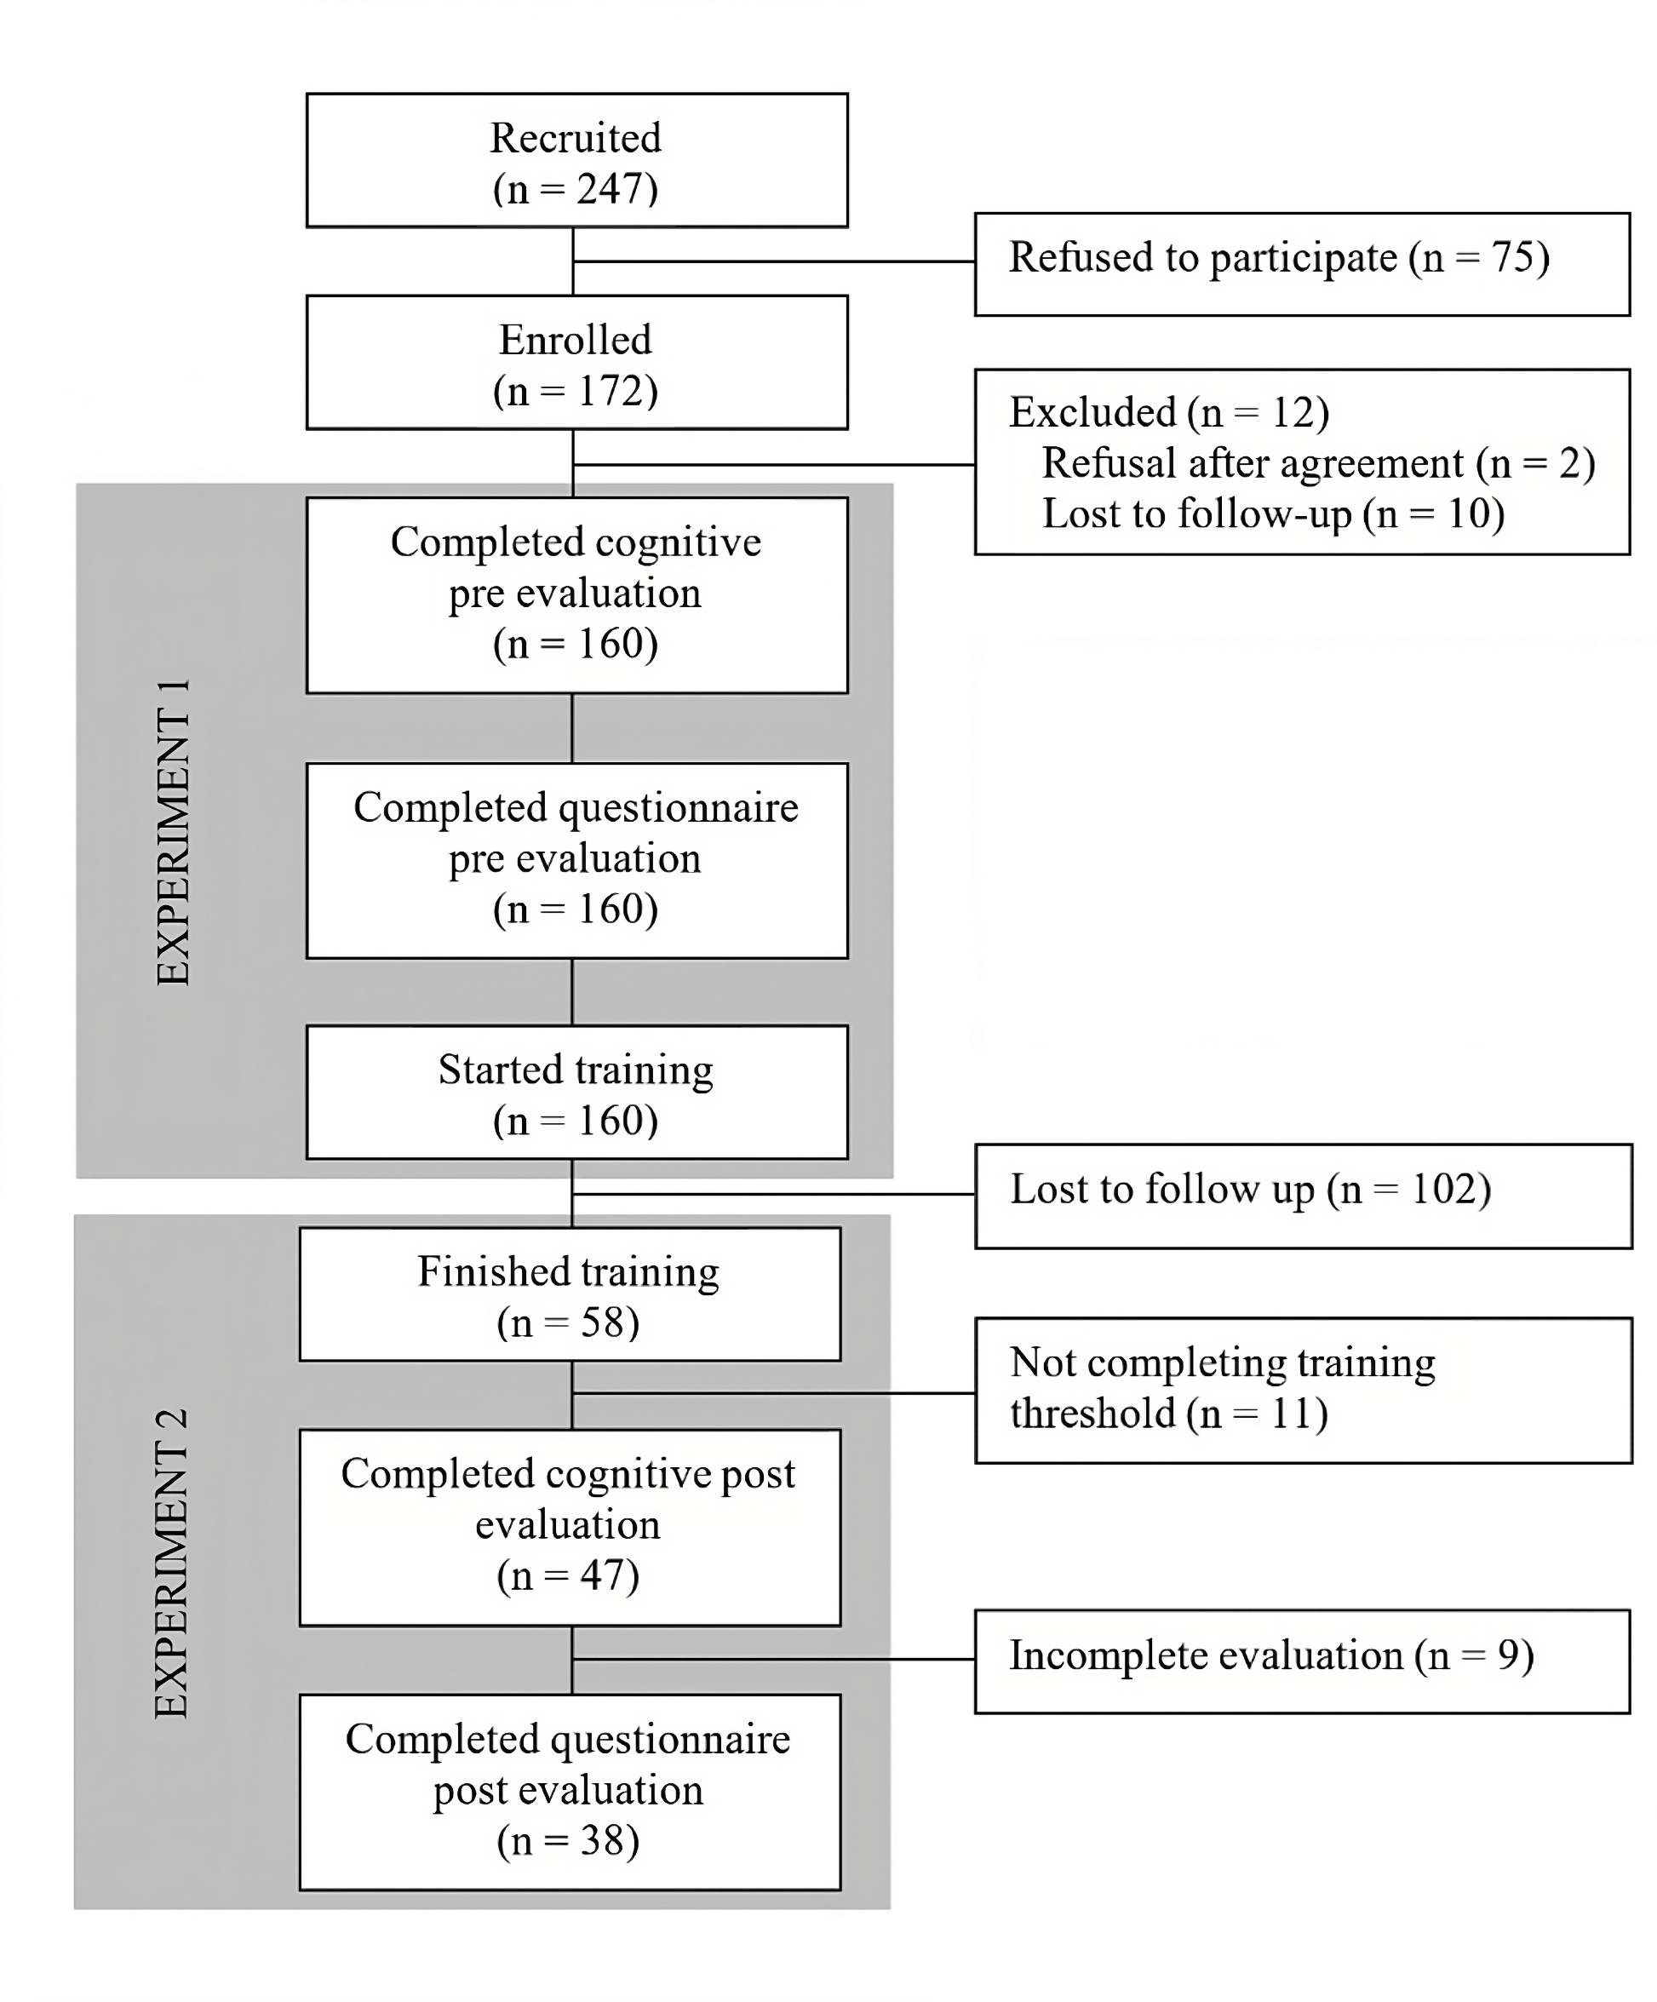

3.1 Associations between cognitive and driving performance
In Experiment 1, we explored the interconnections between specific cognitive domains (attention, perception, memory, reasoning, and coordination) and key driving performance indicators (Total Accident Rate - TAR, Driver-Attributed Crashes - DAC, Speed Overrun Rate - SOR, and sudden Acceleration/Deceleration Rate - ADR). To provide context for these analyses, the driving performance indicators exhibited the following descriptive statistics: TAR (M = 0.762, SD = 1.16), DAC (M = 0.381, SD = 0.82), SOR (M = 0.018, SD = 0.08), and ADR (M = 222.975, SD = 428,71). Figure 3 visualizes the distribution and variability of each metric, providing a clear depiction of the data spread and central tendencies. As all variables were found to follow a non-normal distribution (assessed via the Shapiro-Wilk test), non-parametric correlation analyses using Kendall's Tau were conducted to examine the magnitude and direction of associations between the cognitive abilities and driving metrics, with p-values additionally adjusted using the Benjamini-Hochberg false discovery rate procedure. Following this exploratory phase, a regression model was formulated to scrutinize the influence of these cognitive faculties on driving performance measures more closely. All statistical analyses were conducted using jamovi software [38].
Figure 3. Jittered data plots showing the distribution of Total Accident Rate (TAR), Driver-Attributed Crashes (DAC), Speed Overrun Rate (SOR), and sudden Acceleration/Deceleration Rate (ADR).
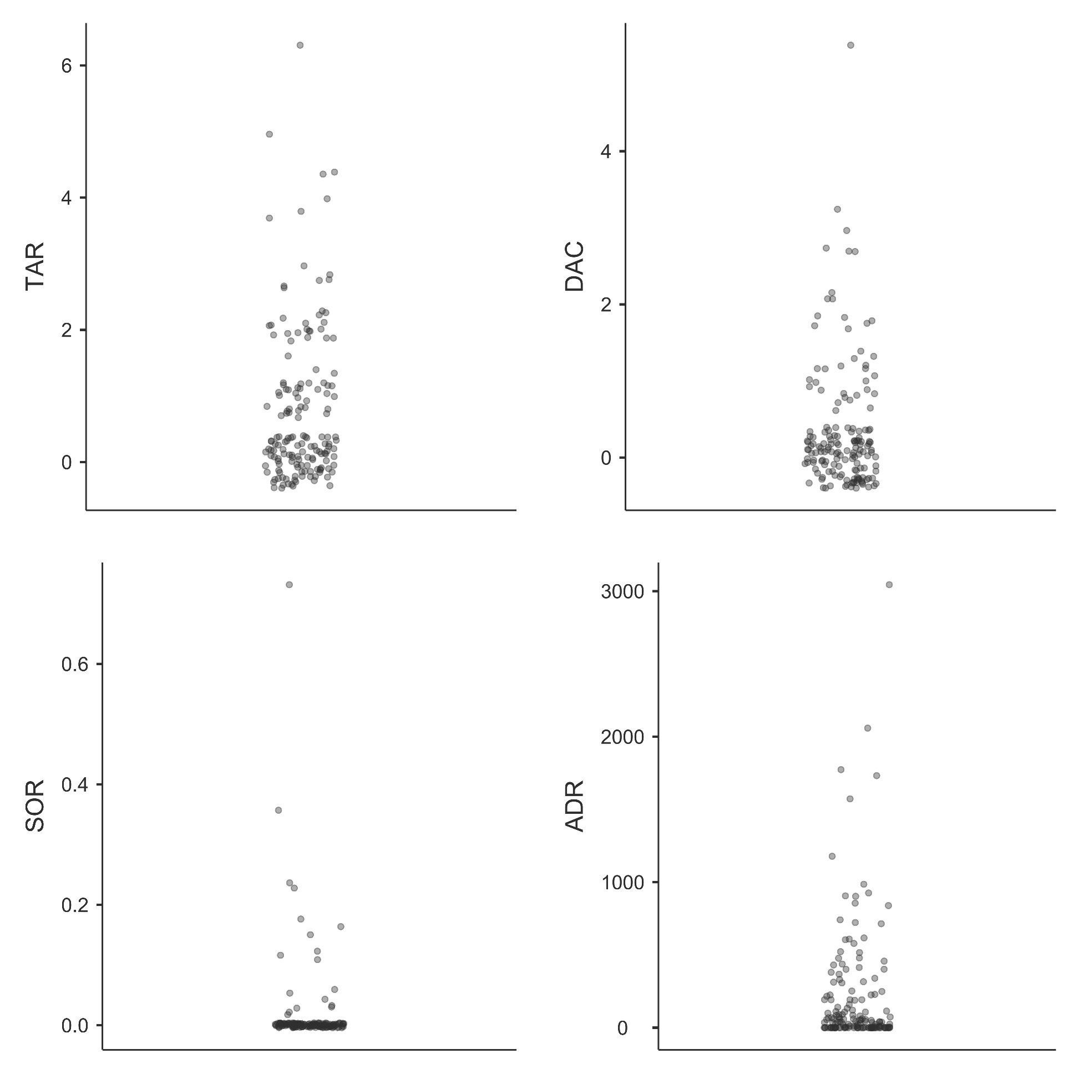
The strongest association was the inverse relationship identified between coordination capabilities and the TAR (τ = -.163, p = .002, qFDR= .030), indicating that enhanced coordination was associated with fewer traffic incidents, independent of fault attribution. This association remained significant after Benjamini-Hochberg false discovery rate correction, with an effect size suggesting a small but meaningful relationship (refer to Table 3 for comprehensive details). To expand upon these insights, a linear regression analysis was executed, focusing on the impact of coordination subdomains – specifically, eye-hand coordination and response time – on the TAR. The results from this model demonstrated a modest level of explanatory power (R = 0.199, R² = .040), indicating that 4% of the variance in TAR could be explained by the predictors. The coefficients further illustrate the relative contributions of these predictors: Eye-Hand Coordination (Estimate = -0.00611, SE = 0.00361, t = -1.69, p = .093) and Response Time (Estimate = -0.00681, SE = 0.00369, t = -1.84, p = .067). This outcome advocates for a holistic examination of cognitive abilities in influencing driving safety, underscoring the premise that these skills collectively contribute to safer driving practices rather than their isolated effects.
Table 3. Kendall’s Tau correlation matrix of cognitive domains and driving performance metrics
 |  | Attention | Perception | Memory | Reasoning | Coordination
TAR | Kendall’s Tau B | -0.086 | -0.043 | -0.069 | -0.096 | -0.163*
 | p-value | 0.106 | 0.416 | 0.193 | 0.073 | 0.002
 | qFDR | 0.398 | 0.780 | 0.478 | 0.365 | 0.030
DAC | Kendall’s Tau B | -0.004 | 0.030 | -0.000 | -0.030 | -0.096
 | p-value | 0.936 | 0.571 | 0.993 | 0.574 | 0.072
 | qFDR | 0.993 | 0.834 | 0.993 | 0.834 | 0.365
ADR | Kendall’s Tau B | -0.072 | 0.024 | -0.027 | -0.067 | 0.016
 | p-value | 0.189 | 0.667 | 0.621 | 0.223 | 0.772
 | qFDR | 0.478 | 0.834 | 0.834 | 0.478 | 0.891
Note¹: * qFDR < .05, ** qFDR < .01, *** qFDR < .001.
Note²: The SOR variable is not presented in the table as all its comparisons yielded undefined (NaN) values due to insufficient variability in the data.
Note³: TAR = Total Accident Rate, DAC = Driver-Attributed Crashes, SOR = Speed Overrun Rate, and ADR = sudden Acceleration/Deceleration Rate.

3.2 Cognitive training intervention outcomes
In Experiment 2, the dedication exhibited by participants towards the cognitive training regimen was notably robust, evidenced by an average attendance of 80.9 sessions (SD = 55.9) spanning approximately 41.6 days on average (SD = 23.3), resulting in a mean total engagement duration of 942 minutes (SD = 651). Upon meticulous scrutiny of participants' engagement patterns in the training program, a correlation emerged showing higher cognitive improvements as a function of the distribution of training sessions over multiple days (r = 0.96, p = .043), with a very large effect size (R² = .921).
Our statistical analysis employed a Repeated Measures ANOVA model with two within-subjects factors: Cognitive Domain (with the levels of memory, attention, perception, reasoning, and coordination) and Evaluation Time (with the levels pre- and post-intervention, referring to the time points at which cognitive performance was measured). The results revealed a significant effect of Cognitive Domain, F(4, 180) = 11.15, p < .001, ηp² = .195. Post hoc analyses showed that the scores in coordination and reasoning did not differ from each other, both being significantly lower than scores in memory, attention, and perception (all p_{bonf} < .05). The main effect of Evaluation Time was also significant, F(1, 45) = 72.41, p < .001, ηp² = .612, highlighting generalized improvements across all cognitive domains following the intervention (see Figure 4).
Figure 4. Estimated marginal means of Cognitive Performance across Cognitive Domain and Evaluation Time. Error bars indicate the 95% confidence intervals for each cognitive domain measured
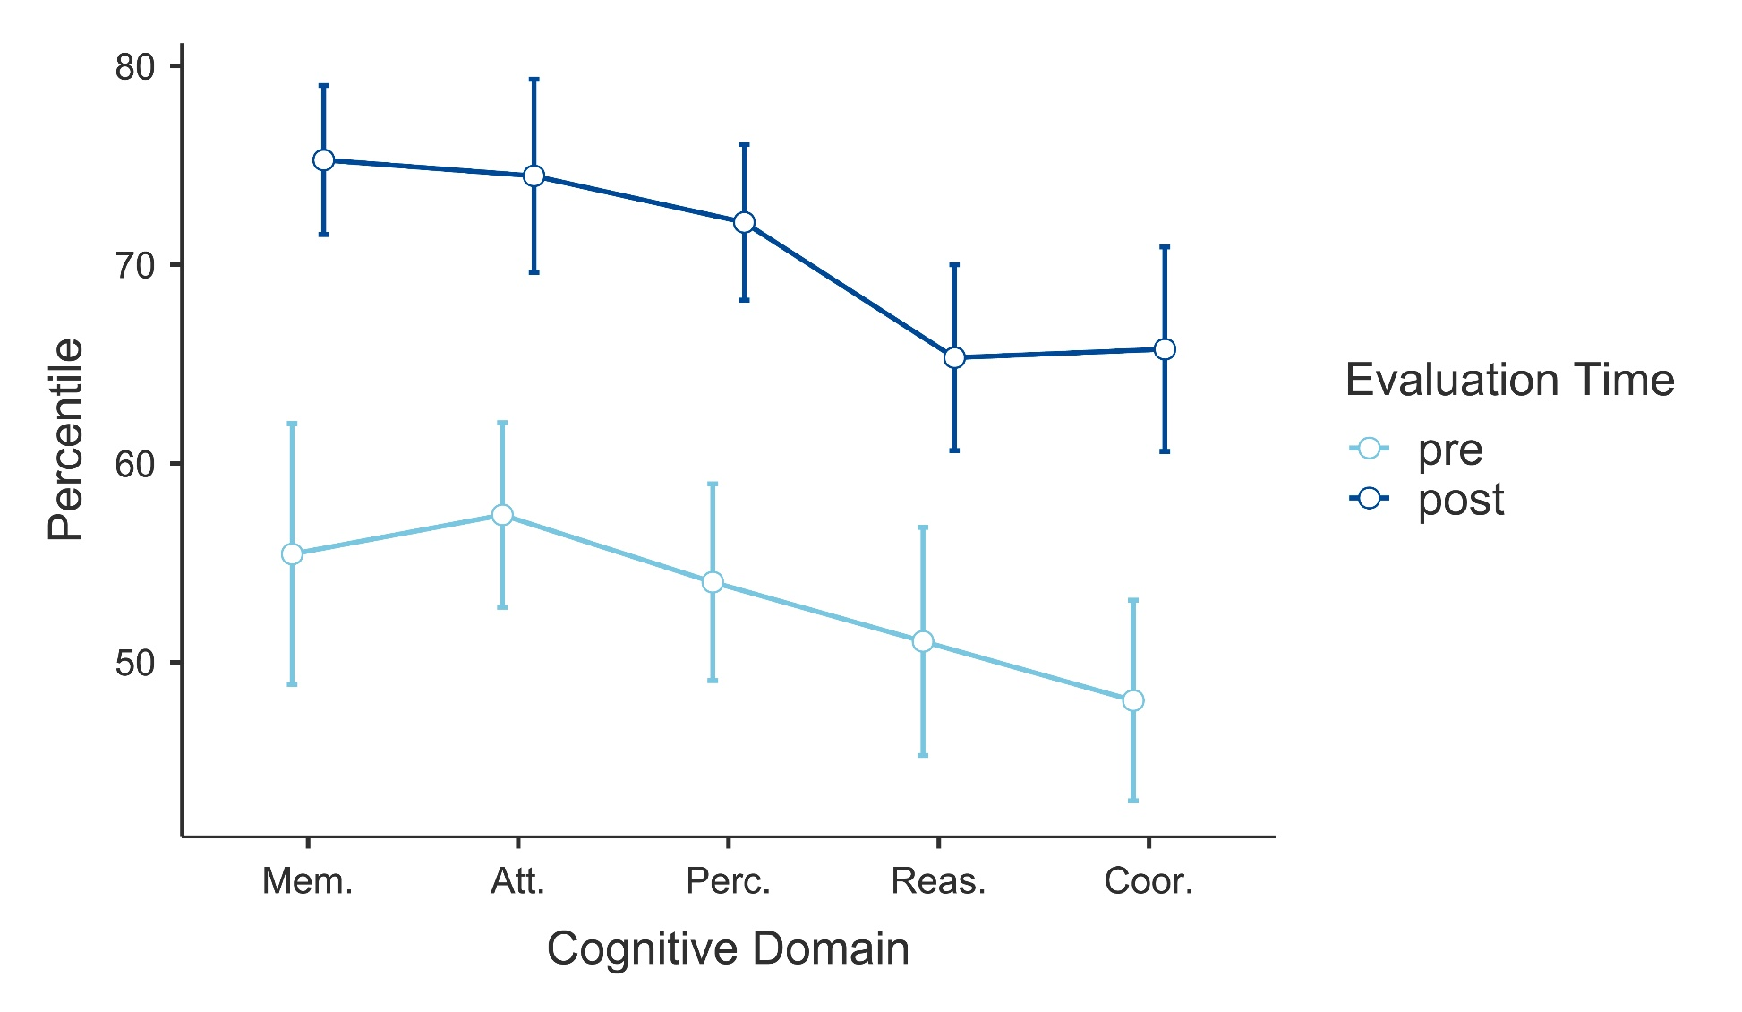
The analysis also considered the interaction between Cognitive Domain and Evaluation Time, which did not show significant differences (F(4, 180) = 1.03, p = .391), indicating that the improvements were consistent across the different domains over time (see Figure 5 for pre vs post results by domain).
Figure 5. Pre- and post-intervention enhancements by cognitive domains. X-axis represents the percentile
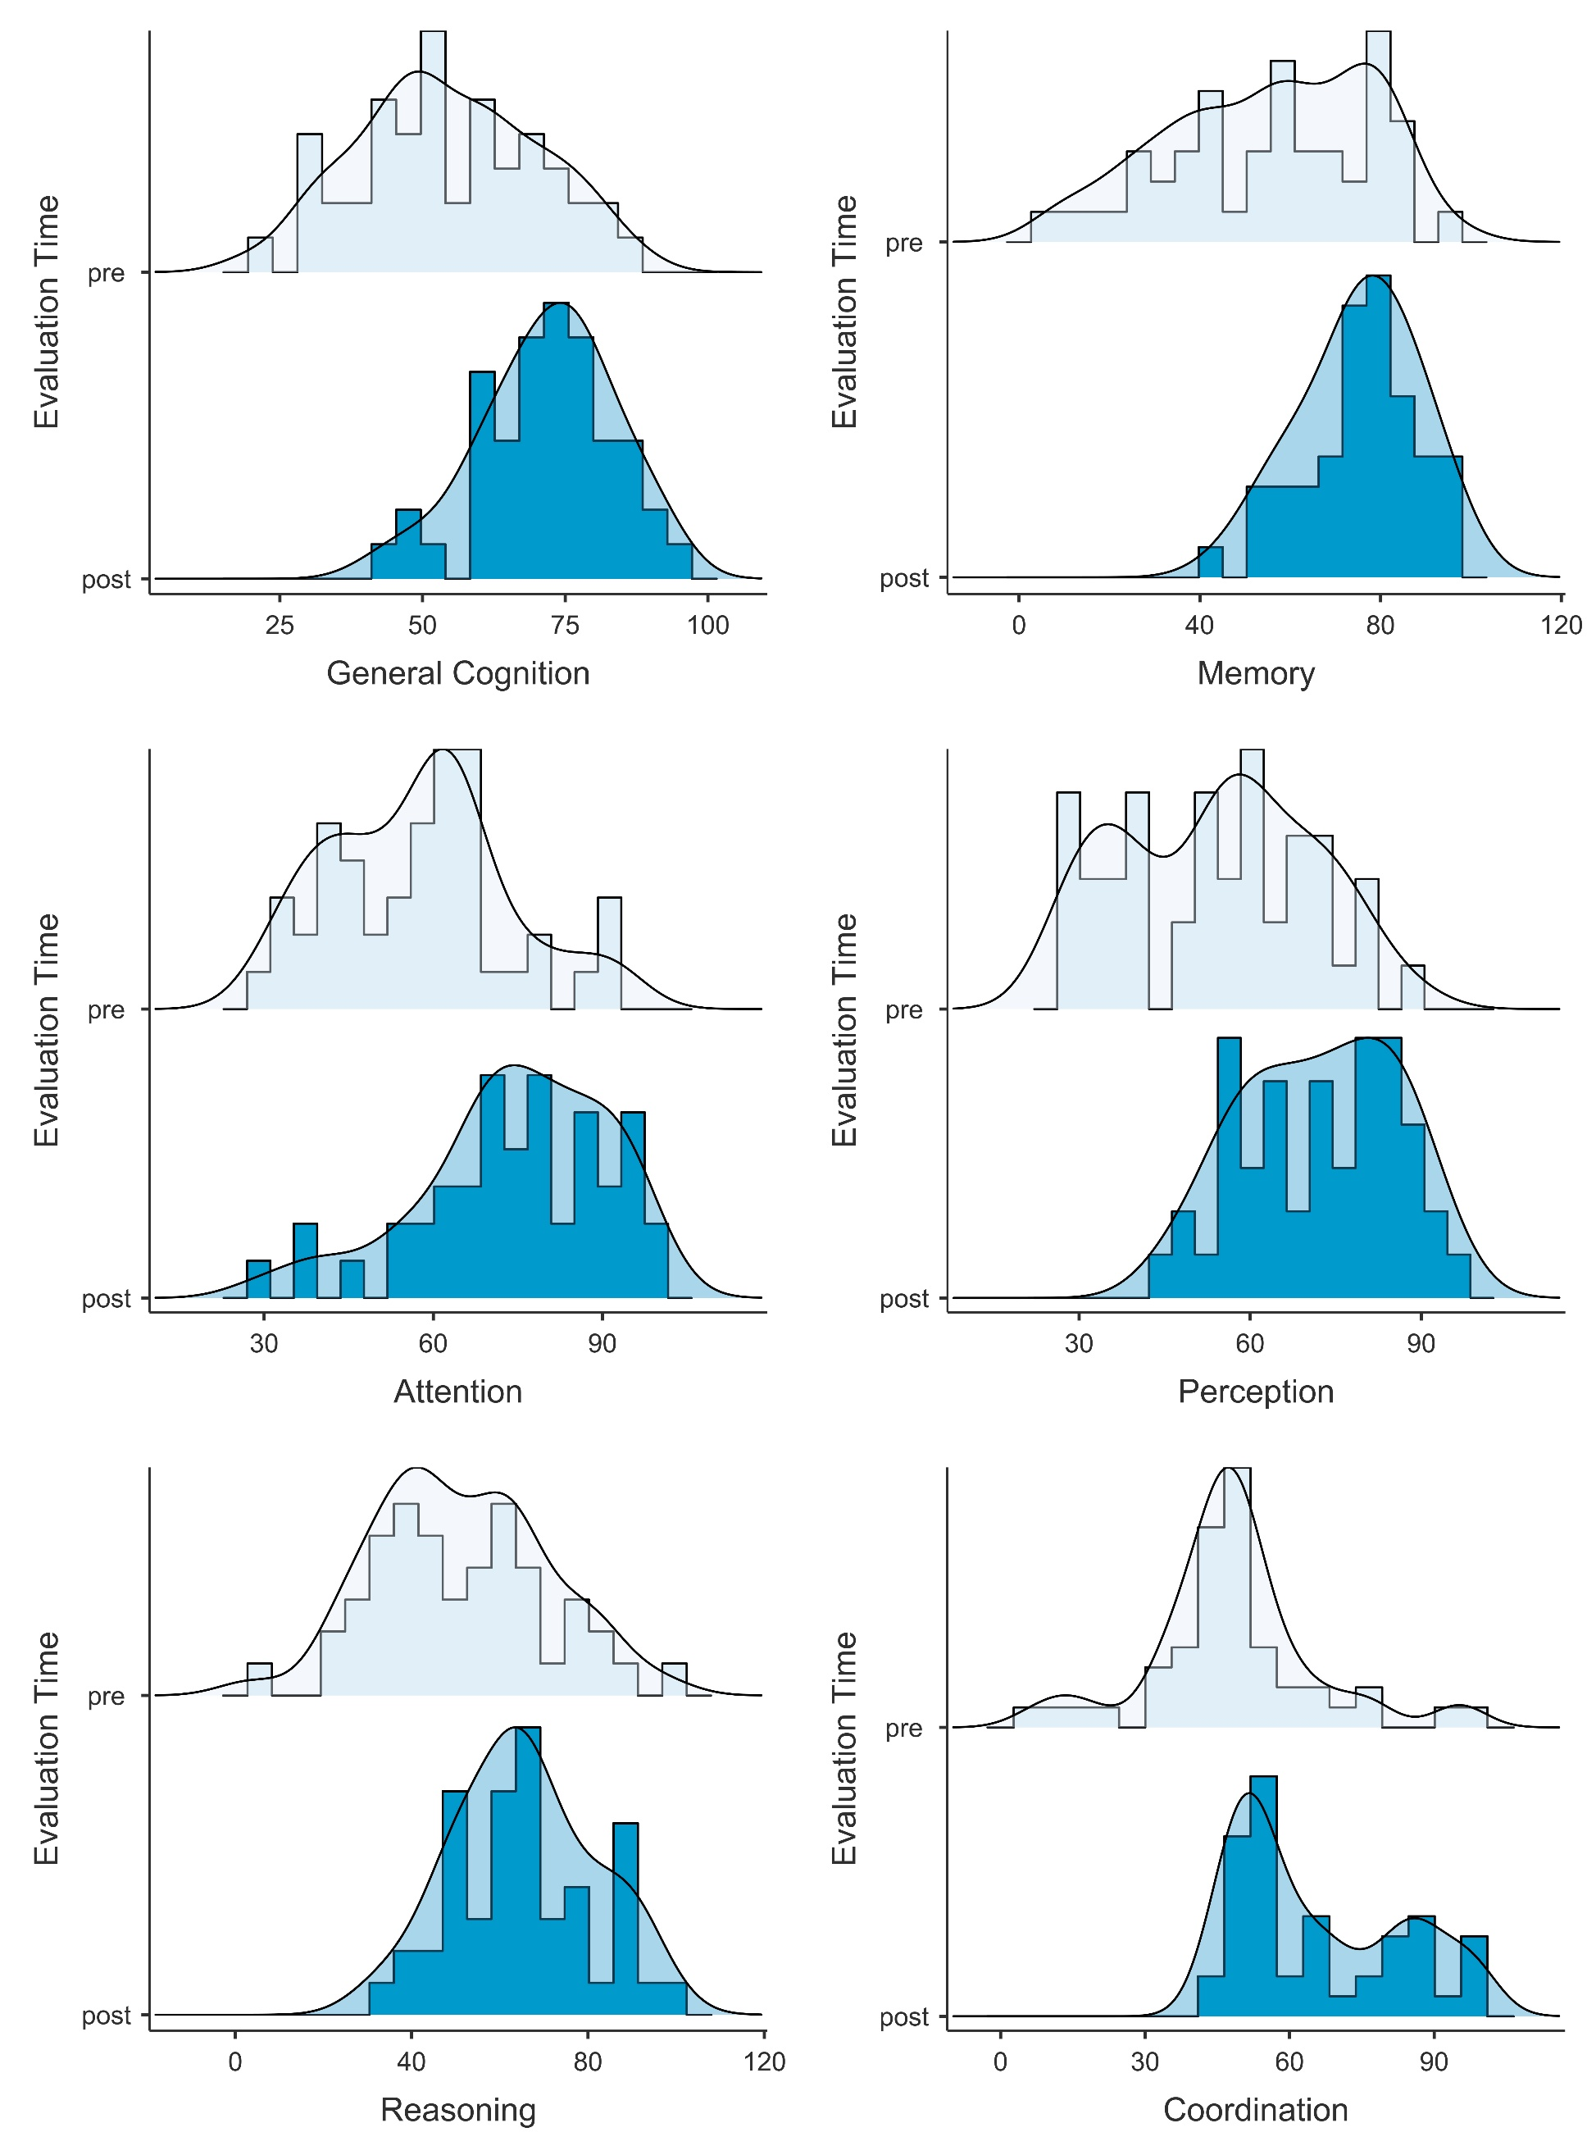
A second Repeated Measures ANOVA with two within-subjects factors: Driving Performance Metric (with the levels of Total Accident Rate - TAR, Driver-Attributed Crashes - DAC, Speed Overrun Rate - SOR, and sudden Acceleration/Deceleration Rate - ADR) and Evaluation Time (with the levels pre- and post-intervention) was conducted to analyze driving performance metrics from the 6 months before and after the cognitive training intervention. The results indicated no significant differences in driving performance metrics across the two time points (F(1, 45) = 2.11, p = 0.153).
Furthermore, in the analysis of driving styles pre- and post-intervention, the Wilcoxon Signed-Rank Test was chosen to account for the non-normative distribution in the paired sample data. The results revealed no statistically significant alterations across any of the domains: aggressive driving style (W = 81.0, p = .846), cautious driving style (W = 42.0, p = .830), fearful driving style (W = 143.5, p = .120), motivation (W = 14.5, p = .660), and adherence to regulatory norms (W = 18.0, p = .608), indicating a stable pattern post-intervention.
Descriptive statistics, including the mean and standard deviation for all pre- and post-intervention variables, are summarized in Appendix C.

4. Discussion
This pilot study set out to explore an under-researched yet highly relevant area in driving safety research: the role of cognitive profiling in understanding professional drivers’ performance and the feasibility of cognitive training interventions in this context. This focus on cognitive foundations responds to their significant influence on driving behavior, an area often overlooked despite legislative efforts like Directive 2022/2561 of the European Parliament.
After examining 22 cognitive skills of professional drivers and their relationship with driving performance measures – including crash rates, exceeding speed limits, and sudden acceleration or braking – the results revealed a potential link between coordination abilities and crash rates, supporting existing literature that connects cognitive abilities with driving safety. Research using driving simulators has also found similar relationships between cognitive parameters and driving. Various studies revealed that visuospatial ability can predict speeding, executive function can predict lane deviation, and attention and visuospatial ability together can predict overall driving performance [30]. Specifically, a study by Sun et al. [32] found that visual-motor coordination significantly influences driving. This finding is supported by another study which showed that coordination and memory capabilities are predictive of traffic violations among young drivers in simulated challenging scenarios [11]. Therefore, CCT may hold promise for reducing the risk of traffic-related offenses and crashes while addressing the cognitive foundations of safe driving behavior.
The literature on the effectiveness of cognitive training typically differentiates between near- and far-transfer effects. Near-transfer refers to the benefits of tasks directly targeted by the training, such as improving memory after specific memory exercises (e.g., remembering word lists). On the other hand, far-transfer effect refers to the transfer of improvement to perform another task in a different context, such as learning a new language. In Experiment 2 of our study, we investigated both near- and far-transfer effects in a driving context. As per the near-transfer effects, our results provide support for the cognitive benefits of CCT in augmenting overall cognitive functionality, as evidenced by substantial enhancements across cognitive domains including attention, perception, memory, reasoning, and coordination. While there is ongoing debate about the ideal length and frequency of CCT sessions [39], our research provides valuable insights into this issue. Specifically, we found that training regimens involving brief sessions distributed across multiple days yield better outcomes. This finding supports a methodology emphasizing regular engagement over an extended timeframe, which aligns with existing recommendations for an eight-week minimum duration and continuous practice [40]. While further exploration is needed to refine these conclusions, our study offers a promising direction for future research and practical applications of cognitive training programs.
However, despite encountering consistently large effect sizes for all cognitive domains, our investigation did not detect significant shifts in driving performance metrics after the CCT intervention. This lack of transferability could be explained by several factors. Most previous research that assessed far-transfer effects has been conducted on the older population and conventional drivers [41,42], limiting its generalizability. In our study, due to the professional profile of the sample, the window for improvement was very narrow. The average crash rate in the 12 months assessed during the study was 0.762, which was also similar across the other metrics (see Appendix C). For instance, two of the driving performance variables referred to rates normalized by kilometers traveled—namely, the rate of time spent exceeding speed limits per kilometer traveled and the rate of sudden acceleration or deceleration events per kilometer traveled. These normalized metrics may have smoothed the incidence of events, making it harder to detect significant changes. For future studies, it might be more relevant to consider total frequency rates instead, as they could better capture variability in driving performance.
Regarding previous studies that have found cognitive training transfer to driving tasks, they generally occurred in artificial-ish settings. For example, in Roenker et al. [20], the driving metrics in simulation involved pressing the brake pedal when a red light appeared on the screen and performing a flanker task where participants had to turn the steering wheel in the direction of an arrow. Another study using cognitive training with TV-based games displayed the tasks within a driving context. For instance, the interface simulated being inside a vehicle, and participants had to press a button when an object disappeared behind another on the road [21]. Additionally, the driving performance was assessed by a driving instructor, which, despite following a checklist, is subject to some degree of subjectivity. Nozawa and colleagues [43] also demonstrated improvements in driving performance following cognitive training. However, driving aptitude was assessed via a computer test on tasks such as simple response, selective response, handling operation, and divided attention to multiple tasks, lacking an on-road driving transfer evaluation. In Cassavaugh and Kramer’s study [44], cognitive training was not gamified and was conducted using a computer with a steering wheel and pedals, while driving performance evaluation was carried out in a simulator. Furthermore, the evaluation tasks were similar to those trained. For example, a selective visual attention training task involved pressing a button on the steering wheel when a motorcycle silhouette appeared in a specific area—peripheral detection. Similarly, a driving evaluation task required pressing a button on the steering wheel when an oncoming vehicle was of a specific color. Therefore, results of previous studies showed benefits on selective simulated driving tasks, but their transfer to real-life safe driving performance remains to be established. In contrast to these simulator-based or lab-constrained evaluations, the present pilot study incorporated real-world driving data, providing preliminary insights into the challenges of translating cognitive gains into measurable behavioral outcomes in naturalistic conditions.
Another factor to consider is the brevity of our intervention, which might have played a role in the absence of noticeable changes in driving performance. Existing literature suggests that prolonged periods of cognitive training are necessary to bring about substantial behavioral transformations, particularly in complex activities such as driving, which may not be evident following short-term interventions [45,46]. Therefore, to modify deep-seated driving behaviors, interventions might need to be more focused or inclusive, extending beyond cognitive enhancement to also consider behavioral and emotional dimensions of driving. Future research could benefit from exploring the integration of CCT with behavioral therapy or emotional regulation training to achieve a more holistic improvement in driving practices, tackling the complex relationship between cognition and behavior to effectuate meaningful changes in driving performance among professional drivers.
Regarding driving styles, our sample exhibited behavior consistent with the literature, which indicates that more experienced drivers tend to adopt cautious and relaxed driving patterns, characterized by low anxiety and appropriate responses to traffic demands [17,18]. Specifically, participants were characterized by cautious driving (M = 4.711), high rule compliance (M = 4.711), and being highly motivated towards driving (M = 5.605). In contrast, they reported being minimally aggressive (M = 0.526) and having a low fearful driving style (M = 0.895). As expected, driving styles remained stable after the intervention, with no significant changes observed in any of the evaluated domains [47].
It is essential to acknowledge certain limitations within our study, which are crucial for contextualizing our findings within the broader scope of cognitive training research. While our overall sample was predominantly male, this reflects the gender distribution of the professional driving sector. Nevertheless, women, who represent approximately 16–18% of bus and coach drivers, were underrepresented in the intervention subsample [48]. This imbalance limits the generalizability of the intervention-related findings, particularly with respect to potential gender-specific effects, and may affect their applicability to broader driver populations, including non-professional drivers and different age groups. Moreover, although our study employed objective real-life metrics, such as crash rates, adherence to speed limits, and acceleration or braking patterns, additional complementary measures could provide deeper insights into the far-transfer effects of cognitive training. For instance, integrating eye-tracking data to analyze visual-attentional patterns during real-world driving could enhance our understanding of how cognitive training influences situational awareness and decision-making. Similarly, behavioral markers such as response patterns to unexpected hazards or near-miss incidents recorded through telematics could offer valuable information on subtle improvements in driving performance. These complementary approaches could refine future studies, enabling a more comprehensive evaluation of the impact of CCT on driving safety. Additionally, the absence of a control group in our study design introduces potential biases, limiting our capacity to definitively attribute the observed changes in cognitive performance directly to the CCT intervention. Without a comparative baseline provided by a control group, it becomes challenging to discern the specific effects of the intervention from other external variables or natural cognitive fluctuations over time. In this context, practice effects and familiarization with the computerized assessment may also have contributed to the observed pre-post cognitive improvements, as repeated neuropsychological testing can lead to performance gains that are not exclusively attributable to true cognitive change [49].
Notwithstanding its limitations, the current work presents a primary practical implication in terms of policy recommendations. Given the significant role of cognitive functions in instrumental tasks, including safe driving, we advocate for policy recommendations to consider cognitive assessments in the processes of obtaining and renewing driver's licenses. Similarly, periodic evaluations would help identify drivers who might be at risk. From a theoretical perspective, the significant correlations between specific cognitive abilities and driving safety metrics can inform and refine theoretical models of driver behavior by better incorporating cognitive factors. Our results contribute to the ongoing debate in cognitive science regarding the transfer of training effects. While CCT improved cognitive functions, the absence of behavioral transfer highlights the need to better understand the mechanisms that support effective generalization in ecologically valid contexts, especially within professional driver populations.

5. Conclusion
This pilot study provides quantitative evidence for the role of cognitive processes in professional driving safety, identifying coordination abilities as a significant predictor of real-world crash incidence. The computerized cognitive training intervention produced consistent improvements across multiple cognitive domains, demonstrating clear near-transfer effects at the cognitive level. However, these gains did not translate into measurable changes in naturalistic driving performance metrics, suggesting limited far-transfer in an experienced professional driver population with relatively high baseline safety. These findings indicate that cognitive training alone may be insufficient to modify real-world driving outcomes in the short term and highlight the need for future research combining cognitive, behavioral, and educational approaches, as well as longer follow-up periods, to better assess the potential impact of cognitive enhancement on driving safety.

Declarations

Author contributions
Conceptualization: J.L.T., P.F., J.A.D.; Data curation: J.L.T.; Formal analysis: J.L.T., J.A.D.; Funding acquisition: J.L.T., J.A.D.; Investigation: J.L.T., P.F.; Methodology: J.L.T., P.F., J.A.D.; Resources: J.A.D., P.F.; Writing – original draft: J.L.T.; Writing – review & editing: J.L.T., P.F., J.A.D.

Ethical approval
The study was approved by the Research Ethics Committee (Comité de Ética en Investigación – CEI) of Nebrija University, adhering to the principles of the Declaration of Helsinki, and was assigned the code UNNE-2022-0014.

Consent to participate
All participants received detailed information about the study and voluntarily provided their written informed consent.

Consent to publish
Not applicable.

Clinical trial number
Not applicable.

Funding
This research was funded by grants FPU19/02239, JDC2023-052644-I and PID2024-161331NB-I00 by the MCIN/AEI/10.13039/501100011033.

Data availability
The data that support the findings of this study are available from the corresponding author upon reasonable request.

Conflicts of Interest
The authors declare no conflict of interest.

Acknowledgements
The authors extend their sincere appreciation to Alsa for their invaluable logistical support and for facilitating access to the participant sample.

Appendices
Appendix A. Cognitive domain and skill breakdown from the Cognitive Assessment Battery
 | Cognitive Domain | Cognitive Skill
General Cognition | Memory | Naming
General Cognition | Memory | Phonological short-term memory
General Cognition | Memory | Visual short-term memory
General Cognition | Memory | Nonverbal memory
General Cognition | Memory | Contextual memory
General Cognition | Memory | Working memory
General Cognition | Memory | Short term memory
General Cognition | Attention | Inhibition
General Cognition | Attention | Divided attention
General Cognition | Attention | Focus attention
General Cognition | Attention | Updating
General Cognition | Perception | Auditory perception
General Cognition | Perception | Estimation
General Cognition | Perception | Recognition
General Cognition | Perception | Spatial perception
General Cognition | Perception | Visual perception
General Cognition | Perception | Visual scanning
General Cognition | Reasoning | Processing speed
General Cognition | Reasoning | Planning
General Cognition | Reasoning | Shifting
General Cognition | Coordination | Hand-eye coordination
General Cognition | Coordination | Response time

Appendix B. Overview of driving style questionnaire
Category | Question
Rules Compliance | Do you respect other drivers on the road?
Rules Compliance | Do you always try to follow traffic signs and rules?
Rules Compliance | Do you abide by the speed limit?
Rules Compliance | Has it been more than one year since your last traffic fine?
Rules Compliance | Are you able to control your stress when you drive?
Motivation | Do you keep driving for 2-3 hours without getting tired (drowsiness, eye discomfort, mental fatigue)?
Motivation | Do you adapt well to the changes and unforeseen events that may arise during a trip (traffic jams, weather changes, car breakdowns)?
Motivation | On long trips, do you volunteer to drive?
Motivation | Does driving relax you?
Motivation | Do you like to drive and enjoy driving a vehicle?
Motivation | Do you tend to stay calm in traffic jams or when another driver blocks the road?
Fearful Driving Style | Do you often think about getting in a car accident?
Fearful Driving Style | Do you think that driving is dangerous?
Fearful Driving Style | Are you nervous or scared to drive at night?
Fearful Driving Style | Do you get nervous about long road trips?
Fearful Driving Style | Do you get scared when you have to pass larger vehicles on the road?
Cautious Driving Style | Do you check the tire pressure, fill up on gas, and look at the forecast before starting a long road trip?
Cautious Driving Style | Before passing a car on the road, do you check to make sure that you're able to do so safely?
Cautious Driving Style | Do you think that patience and prudence are important when it comes to driving?
Cautious Driving Style | Do you often think about the possible consequences that your actions may have?
Cautious Driving Style | Do you prefer driving calmly, while enjoying the views and the driving itself?
Agressive Driving Style | Do you like to see how fast your car can go?
Agressive Driving Style | Do you like to participate in risky activities just for fun?
Agressive Driving Style | Would you like to have a fast sports car?
Agressive Driving Style | Do you usually insult other drivers when they do something that you think is dangerous or wrong?
Agressive Driving Style | Do you get impatient when things go slowly or take too long?

Appendix C. Descriptive statistics for pre- and post-evaluation metrics
Category | Variable | N | M_{pre} | SD_{pre} | M_{post} | SD_{post}
Cognitive Domains | Memory | 47 | 55.4 | 22.4 | 75.3 | 12.8
Cognitive Domains | Attention | 47 | 57.4 | 15.8 | 74.5 | 16.6
Cognitive Domains | Perception | 47 | 54.0 | 16.9 | 72.1 | 13.3
Cognitive Domains | Reasoning | 47 | 51.0 | 19.5 | 65.3 | 15.9
Cognitive Domains | Coordination | 47 | 48.1 | 17.2 | 65.8 | 17.5
Driving Metrics | TAR | 46 | 0.348 | 0.74 | 0.478 | 0.84
Driving Metrics | DAC | 46 | 0.152 | 0.47 | 0.326 | 0.70
Driving Metrics | SOR | 46 | 0.094 | 0.40 | 0.68 | 0.29
Driving Metrics | ADR | 46 | 829.902 | 1603.48 | 2161.990 | 6858.42
Driving Styles | Aggressive Style | 38 | 0.526 | 0.69 | 0.553 | 0.76
Driving Styles | Cautious Style | 38 | 4.711 | 0.46 | 4.684 | 0.53
Driving Styles | Fearful Style | 38 | 0.895 | 0.76 | 0.684 | 0.66
Driving Styles | Motivation | 38 | 5.605 | 1.001 | 5.658 | 0.78
Driving Styles | Rules Compliance | 38 | 4.711 | 0.77 | 4.816 | 0.39

References
[1] Eurostat, EU labour force survey – data and publication, European Commission, Online, 2024. https://ec.europa.eu/eurostat/statistics-explained/index.php?title=EU_labour_force_survey_%E2%80%93_data_and_publication.
[2] T.-O. Nævestad, R.O. Phillips, B. Elvebakk, Traffic accidents triggered by drivers at work – A survey and analysis of contributing factors, Transportation Research Part F: Traffic Psychology and Behaviour 34 (2015) 94–107. https://doi.org/10.1016/j.trf.2015.07.024.
[3] J.A. Santos, J.L. Lu, Occupational safety conditions of bus drivers in Metro Manila, the Philippines, International Journal of Occupational Safety and Ergonomics 22 (2016) 508–513. https://doi.org/10.1080/10803548.2016.1151700.
[4] European Commission, Road Safety Thematic Report – Professional drivers of trucks and buses, European Road Safety Observatory, Brussels, European Commission, Directorate General for Transport, 2023. https://road-safety.transport.ec.europa.eu/document/download/e19cf119-eed4-4cb3-b1fd-1fd0b4554992_en?filename=Road_Safety_Thematic_Report_Professional_drivers_trucks_and_buses_2023.pdf.
[5] European Parliament, Directive (EU) 2022/2561 of the European Parliament and of the Council of 14 December 2022 on the initial qualification and periodic training of drivers of certain road vehicles for the carriage of goods or passengers, 2022. http://data.europa.eu/eli/dir/2022/2561/oj/eng (accessed February 27, 2024).
[6] T.A. Dingus, F. Guo, S. Lee, J.F. Antin, M. Perez, M. Buchanan-King, J. Hankey, Driver crash risk factors and prevalence evaluation using naturalistic driving data, Proceedings of the National Academy of Sciences 113 (2016) 2636–2641. https://doi.org/10.1073/pnas.1513271113.
[7] K. Bucsuházy, E. Matuchová, R. Zůvala, P. Moravcová, M. Kostíková, R. Mikulec, Human factors contributing to the road traffic accident occurrence, Transportation Research Procedia 45 (2020) 555–561. https://doi.org/10.1016/j.trpro.2020.03.057.
[8] P.K. Agarwal, P. Kumar, H. Singh, Causes and Factors in Road Traffic Accidents at a Tertiary Care Center of Western Uttar Pradesh, Medico Legal Update 20 (2020) 38–41. https://doi.org/10.37506/mlu.v20i1.321.
[9] S. Živković, V. Nikolić, M. Markič, Influence of professional drivers’ personality traits on road traffic safety: case study, International Journal of Injury Control and Safety Promotion 22 (2015) 100–110. https://doi.org/10.1080/17457300.2013.843571.
[10] O. Prasolenko, O. Lobashov, A. Galkin, The Human Factor in Road Traffic City, The Human Factor in Road Traffic City 1 (2015) 77–84.
[11] J.L. Tapia, J.A. Duñabeitia, Driving safety: Investigating the cognitive foundations of accident prevention, Heliyon 9 (2023) e21355. https://doi.org/10.1016/j.heliyon.2023.e21355.
[12] M.S. Horswill, K.J. Anstey, C. Hatherly, J.M. Wood, N.A. Pachana, Older drivers’ insight into their hazard perception ability, Accident Analysis & Prevention 43 (2011) 2121–2127. https://doi.org/10.1016/j.aap.2011.05.035.
[13] K.J. Anstey, M.S. Horswill, J.M. Wood, C. Hatherly, The role of cognitive and visual abilities as predictors in the Multifactorial Model of Driving Safety, Accident Analysis & Prevention 45 (2012) 766–774. https://doi.org/10.1016/j.aap.2011.10.006.
[14] O. Taubman-Ben-Ari, M. Mikulincer, O. Gillath, The multidimensional driving style inventory—scale construct and validation, Accident Analysis & Prevention 36 (2004) 323–332. https://doi.org/10.1016/S0001-4575(03)00010-1.
[15] F.M. Poó, O. Taubman-Ben-Ari, R.D. Ledesma, C.M. Díaz-Lázaro, Reliability and validity of a Spanish-language version of the multidimensional driving style inventory, Transportation Research Part F: Traffic Psychology and Behaviour 17 (2013) 75–87. https://doi.org/10.1016/j.trf.2012.10.003.
[16] O. Taubman-Ben-Ari, V. Skvirsky, The multidimensional driving style inventory a decade later: Review of the literature and re-evaluation of the scale, Accident Analysis & Prevention 93 (2016) 179–188. https://doi.org/10.1016/j.aap.2016.04.038.
[17] Y. Wang, W. Qu, Y. Ge, X. Sun, K. Zhang, Effect of personality traits on driving style: Psychometric adaption of the multidimensional driving style inventory in a Chinese sample, PLoS One 13 (2018) e0202126. https://doi.org/10.1371/journal.pone.0202126.
[18] H. Hooft van Huysduynen, J. Terken, B. Eggen, The relation between self-reported driving style and driving behaviour. A simulator study, Transportation Research Part F: Traffic Psychology and Behaviour 56 (2018) 245–255. https://doi.org/10.1016/j.trf.2018.04.017.
[19] J. Mishra, A. Gazzaley, Harnessing the neuroplastic potential of the human brain & the future of cognitive rehabilitation, Frontiers in Human Neuroscience 8 (2014). https://doi.org/10.3389/fnhum.2014.00218.
[20] D.L. Roenker, G.M. Cissell, K.K. Ball, V.G. Wadley, J.D. Edwards, Speed-of-Processing and Driving Simulator Training Result in Improved Driving Performance, Hum Factors 45 (2003) 218–233. https://doi.org/10.1518/hfes.45.2.218.27241.
[21] R. Nouchi, A. Kobayashi, H. Nouchi, R. Kawashima, Newly Developed TV-Based Cognitive Training Games Improve Car Driving Skills, Cognitive Functions, and Mood in Healthy Older Adults: Evidence From a Randomized Controlled Trial, Frontiers in Aging Neuroscience 11 (2019). https://doi.org/10.3389/fnagi.2019.00099.
[22] O. Molloy, B.R.C. Molesworth, A. Williamson, Which cognitive training intervention can improve young drivers’ speed management on the road?, Transportation Research Part F: Traffic Psychology and Behaviour 60 (2019) 68–80. https://doi.org/10.1016/j.trf.2018.09.025.
[23] L.A. Ross, S.A. Freed, J.D. Edwards, C.B. Phillips, K. Ball, The Impact of Three Cognitive Training Programs on Driving Cessation Across 10 Years: A Randomized Controlled Trial, The Gerontologist 57 (2017) 838–846. https://doi.org/10.1093/geront/gnw143.
[24] Y. Hayashi, A.M. Foreman, J.E. Friedel, O. Wirth, Executive function and dangerous driving behaviors in young drivers, Transportation Research Part F: Traffic Psychology and Behaviour 52 (2018) 51–61. https://doi.org/10.1016/j.trf.2017.11.007.
[25] H. Zhang, Y. Guo, W. Yuan, K. Li, On the importance of working memory in the driving safety field: A systematic review, Accident Analysis & Prevention 187 (2023) 107071. https://doi.org/10.1016/j.aap.2023.107071.
[26] J.L. Tapia, J.A. Duñabeitia, The Effects of Cognitive Training on Driving Performance, Cognitive Processing (in press).
[27] Z. Dehnabaei, Z. Tabibi, M.C. Ouimet, A. Mohammadzadeh Moghaddam, M. Ebrahimpour Delavar, Computerized cognitive training to improve executive functions and driving skills of adolescents with and without symptoms of attention-deficit/hyperactivity disorder, Transportation Research Part F: Traffic Psychology and Behaviour 105 (2024) 13–23. https://doi.org/10.1016/j.trf.2024.06.019.
[28] G. Adler, M. Kuskowski, Driving Cessation in Older Men With Dementia, Alzheimer Disease & Associated Disorders 17 (2003) 68.
[29] N. Herrmann, M.J. Rapoport, R. Sambrook, R. Hébert, P. McCracken, A. Robillard, Predictors of driving cessation in mild-to-moderate dementia, CMAJ 175 (2006) 591–595. https://doi.org/10.1503/cmaj.051707.
[30] S. Ledger, J.M. Bennett, E. Chekaluk, J. Batchelor, Cognitive function and driving: Important for young and old alike, Transportation Research Part F: Traffic Psychology and Behaviour 60 (2019) 262–273. https://doi.org/10.1016/j.trf.2018.10.024.
[31] D. Apolinario, R.M. Magaldi, A.L. Busse, L. da C. Lopes, J.Y.T. Kasai, E. Satomi, Cognitive impairment and driving: A review of the literature, Dement Neuropsychol 3 (2009) 283–290. https://doi.org/10.1590/S1980-57642009DN30400004.
[32] Q.C. Sun, J.C. Xia, J. He, J. Foster, T. Falkmer, H. Lee, Towards unpacking older drivers’ visual-motor coordination: A gaze-based integrated driving assessment, Accident Analysis & Prevention 113 (2018) 85–96. https://doi.org/10.1016/j.aap.2018.01.019.
[33] A. Lira-Delcore, J.L. Tapia, J.A. Duñabeitia, Assessing the Stability of Cognitive and Attentional Computerized Tests: A Test-Retest Reliability Study, Psychologica 68 (2025) e068007–e068007. https://doi.org/10.14195/1647-8606_68_7.
[34] J.C.C. Olmos, M.M. Hernández, Á.A. Garrido, J.A. Salinas, M. Díaz-Pérez, Effects of a Mediterranean Diet-Based Program on Cognitive Decline: Non-Blinded Non-Randomized Controlled Trial of the CESPORT Program, Nutrients 18 (2026). https://doi.org/10.3390/nu18071073.
[35] J.M. Carmona-Torres, V. Mazoteras-Pardo, E. Santacruz-Salas, A.I. Cobo-Cuenca, E. Barroso-Corroto, S. Rodríguez-Cañamero, J.A. Laredo-Aguilera, Improvements in Cognitive and Health Assessment in People Older Than 60 Years Through Cognitive Training With the CogniFit App, Sage Open 16 (2026) 21582440251405342. https://doi.org/10.1177/21582440251405342.
[36] I. Haimov, E. Shatil, Cognitive Training Improves Sleep Quality and Cognitive Function among Older Adults with Insomnia, PLOS ONE 8 (2013) e61390. https://doi.org/10.1371/journal.pone.0061390.
[37] L. Nguyen, K. Murphy, G. Andrews, A Game a Day Keeps Cognitive Decline Away? A Systematic Review and Meta-Analysis of Commercially-Available Brain Training Programs in Healthy and Cognitively Impaired Older Adults, Neuropsychol Rev 32 (2022) 601–630. https://doi.org/10.1007/s11065-021-09515-2.
[38] The jamovi project, jamovi, (2023). https://www.jamovi.org/.
[39] A. Lauenroth, A.E. Ioannidis, B. Teichmann, Influence of combined physical and cognitive training on cognition: a systematic review, BMC Geriatrics 16 (2016) 141. https://doi.org/10.1186/s12877-016-0315-1.
[40] N.J. Gates, A.W. Rutjes, M. Di Nisio, S. Karim, L. Chong, E. March, G. Martínez, R.W. Vernooij, Computerised cognitive training for maintaining cognitive function in cognitively healthy people in midlife, Cochrane Database Syst Rev 2019 (2019) CD012278. https://doi.org/10.1002/14651858.CD012278.pub2.
[41] J.D. Edwards, B.A. Fausto, A.M. Tetlow, R.T. Corona, E.G. Valdés, Systematic review and meta-analyses of useful field of view cognitive training, Neuroscience & Biobehavioral Reviews 84 (2018) 72–91. https://doi.org/10.1016/j.neubiorev.2017.11.004.
[42] B.N. Sprague, S.A. Freed, C.E. Webb, C.B. Phillips, J. Hyun, L.A. Ross, The impact of behavioral interventions on cognitive function in healthy older adults: A systematic review, Ageing Research Reviews 52 (2019) 32–52. https://doi.org/10.1016/j.arr.2019.04.002.
[43] T. Nozawa, Y. Taki, A. Kanno, Y. Akimoto, M. Ihara, R. Yokoyama, Y. Kotozaki, R. Nouchi, A. Sekiguchi, H. Takeuchi, C.M. Miyauchi, T. Ogawa, T. Goto, T. Sunda, T. Shimizu, E. Tozuka, S. Hirose, T. Nanbu, R. Kawashima, Effects of Different Types of Cognitive Training on Cognitive Function, Brain Structure, and Driving Safety in Senior Daily Drivers: A Pilot Study, Behavioural Neurology 2015 (2015) e525901. https://doi.org/10.1155/2015/525901.
[44] N.D. Cassavaugh, A.F. Kramer, Transfer of Computer-Based Training to Simulated Driving In Older Adults, Proceedings of the Human Factors and Ergonomics Society Annual Meeting 58 (2014) 2043–2047. https://doi.org/10.1177/1541931214581426.
[45] K. Ball, D.B. Berch, K.F. Helmers, J.B. Jobe, M.D. Leveck, M. Marsiske, J.N. Morris, G.W. Rebok, D.M. Smith, S.L. Tennstedt, F.W. Unverzagt, S.L. Willis, for the ACTIVE Study Group, Effects of Cognitive Training Interventions With Older AdultsA Randomized Controlled Trial, JAMA 288 (2002) 2271–2281. https://doi.org/10.1001/jama.288.18.2271.
[46] S.L. Willis, S.L. Tennstedt, M. Marsiske, K. Ball, J. Elias, K.M. Koepke, J.N. Morris, G.W. Rebok, F.W. Unverzagt, A.M. Stoddard, E. Wright, for the ACTIVE Study Group, Long-term Effects of Cognitive Training on Everyday Functional Outcomes in Older Adults, JAMA 296 (2006) 2805–2814. https://doi.org/10.1001/jama.296.23.2805.
[47] J. Sander, F. Schmiedek, A. Brose, G.G. Wagner, J. Specht, Long-Term Effects of an Extensive Cognitive Training on Personality Development, J Pers 85 (2017) 454–463. https://doi.org/10.1111/jopy.12252.
[48] IRU, Global driver shortages: 2023 year in review, International Road Transportation Union, Geneva, 2023. https://www.iru.org/news-resources/newsroom/global-driver-shortages-2023-year-review (accessed June 6, 2024).
[49] M. Calamia, K. Markon, D. Tranel, Scoring Higher the Second Time Around: Meta-Analyses of Practice Effects in Neuropsychological Assessment, The Clinical Neuropsychologist 26 (2012) 543–570. https://doi.org/10.1080/13854046.2012.680913.

